Data Analytics Track – Stage 2A Task: HNG Ride SQL Business Analysis
Business Scenario

Prepared by: BenjaminAZ

OBJECTIVE
The objective of this project is to analyze HNG Ride’s operational data from June 2021 to December 2024 to evaluate business performance and identify areas for improvement.

Insights to Queries of business questions and results.

1. Top 10 Longest Rides
This query retrieves the 10 rides with the greatest travel distances from the completed_rides table. It joins the drivers and rider tables to display the names of both parties, along with pickup and dropoff cities and payment methods.

Screenshot of Scripts.
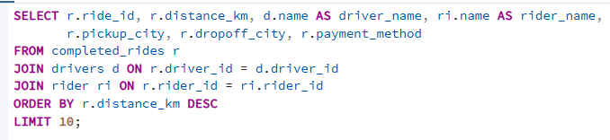

Results.
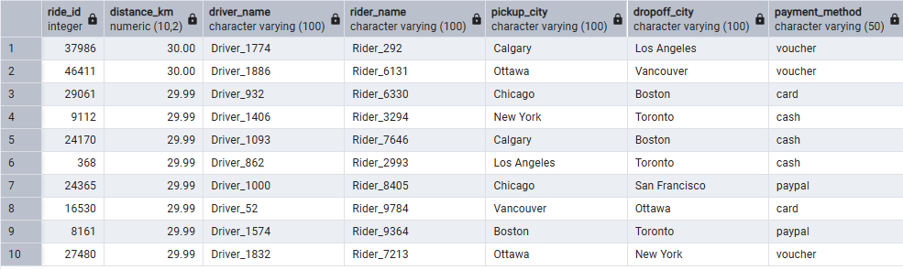

2. How many riders who signed up in 2021 still took rides in 2024?

A total of 1,813 riders who signed up in 2021 were still active in 2024.
Screenshot of scripts.
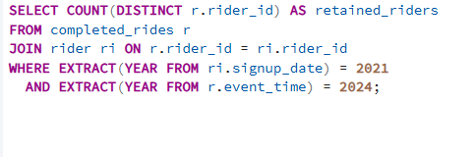
Results
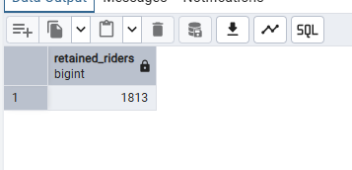
3. Compare quarterly revenue between 2021, 2022, 2023, and 2024. Which quarter had the biggest YoY growth?
The biggest Year-over-Year (YoY) growth occurred between Q2 of 2021 and Q2 of 2022, where revenue increased dramatically from 33,965.96 to 102,168.13, indicating a major expansion or improved ride demand.
Screenshots of the query.
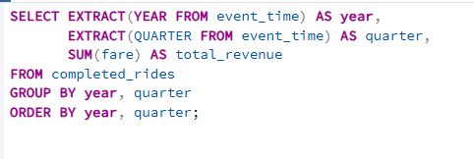
Results.

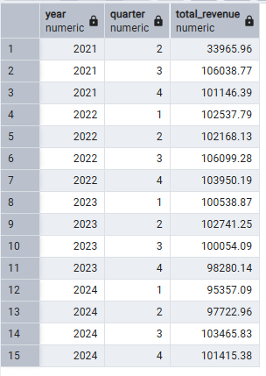
4. Top 5 drivers by consistency
- The most consistent drivers are Driver_1232, Driver_537, and Driver_627, each averaging about 1.73 rides per month.
- Driver_138 and Driver_431 follow closely with averages of 1.70 and 1.69 rides per month, respectively.
Screenshot of query.
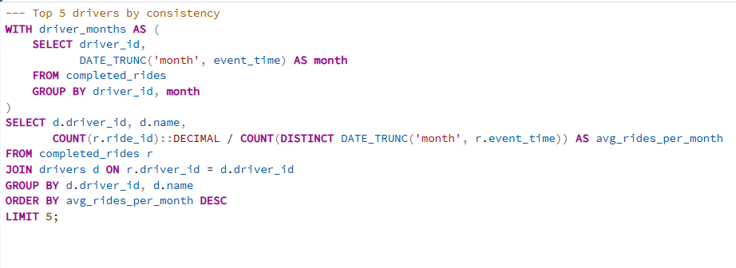
Results.
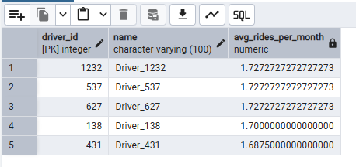
5. Cancellation rate per city
Ottawa, Los Angeles, Chicago, New York, Montreal, Vancouver, N.Y, Toronto, L.A, Calgary, and San Francisco all have equal cancellation rates of 0%.
Screenshot of query.
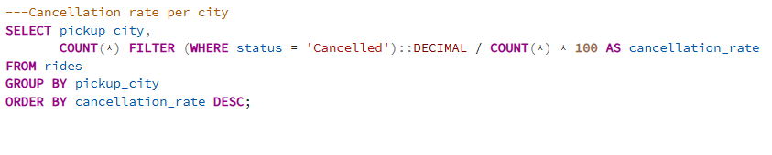
Results
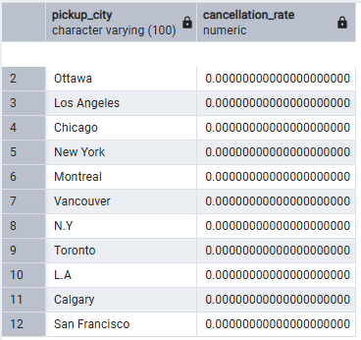
6. Identify riders who have taken more than 10 rides but never paid with cash.
A total of 8 riders have completed more than 10 rides without using cash as their payment method.
Screenshot of query.
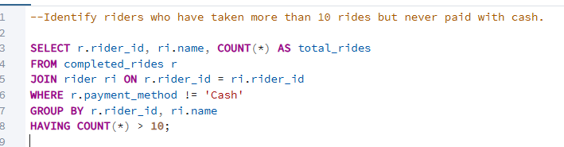
Results.
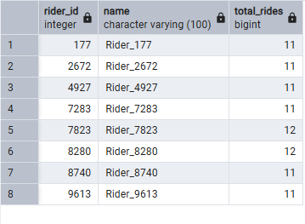
7.Top 3 drivers per city by revenue.
Across all cities, 36 top-performing drivers were identified — representing the top 3 drivers per city based on total revenue earned between June 2021 and December 2024.
Screenshot of query.
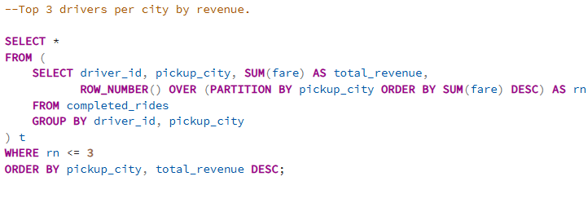
Results
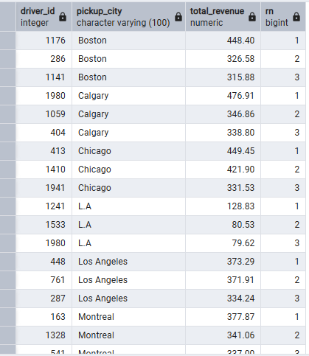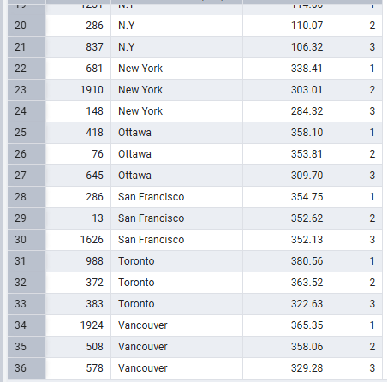
8. The top 10 drivers who are qualified to receive bonuses
Out of all drivers analyzed, only 4 qualified for bonuses based on the set performance criteria (≥30 rides, ≥4.5 rating, <5% cancellation).
Query.
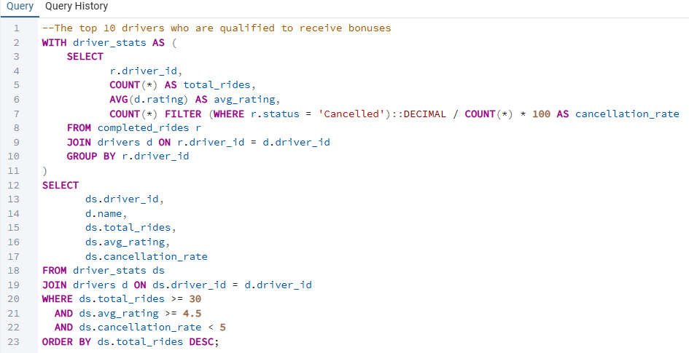
Results.
